**Interval List Intersections**

Given two lists of **closed** intervals, each list of intervals is pairwise disjoint and in sorted order.

Return the intersection of these two interval lists.

*(Formally, a closed interval [a, b] (with a <= b) denotes the set of real numbers x with a <= x <= b.  The intersection of two closed intervals is a set of real numbers that is either empty, or can be represented as a closed interval.  For example, the intersection of [1, 3] and [2, 4] is [2, 3].)*

**Example 1:**

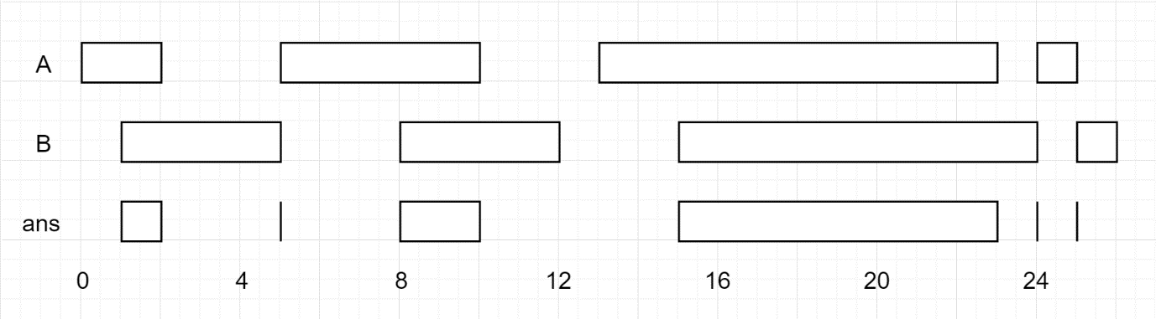

**Input:** A = [[0,2],[5,10],[13,23],[24,25]], B = [[1,5],[8,12],[15,24],[25,26]]

**Output:** [[1,2],[5,5],[8,10],[15,23],[24,24],[25,25]]

**Note:**

1. 0 <= A.length < 1000
2. 0 <= B.length < 1000
3. 0 <= A[i].start, A[i].end, B[i].start, B[i].end < 10^9